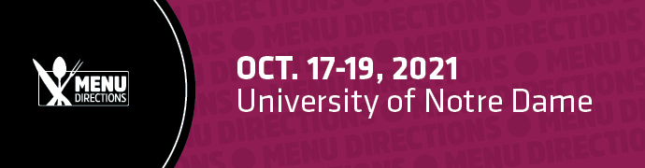

To:
From:
Re: MenuDirections 2021 Registration Request

I am requesting approval to attend the 19th annual MenuDirections conference, taking place October 17-19, 2021 at the University of Notre Dame in South Bend, IN. This is a two-and-a-half-day event full of educational workshops, exciting culinary demos and keynote presentations, all designed to help foodservice directors, from all segments, find solutions that can transform our menus and operations.

The 2021 agenda features more than 20 sessions taught by the industry’s leading experts such as [speaker name], [speaker name] and [speaker name]. Plus, several sessions focus on key areas I am interested in learning more about, including: [session title], [session title] and [session title].

MenuDirections is the event for noncommercial foodservice operators and the place to cultivate meaningful business relationships while gathering insights. The trends, solutions, best practices and case studies featured at the conference will enhance my ability to do my job and take our business to the next level.
And, MenuDirections will be offering Continuing Education Units (CEUs).

Attending MenuDirections in 2021 will particularly help me with the following:
- [add project or initiative]
- [add project or initiative]
- [add project or initiative]

With the generous support of MenuDirections’ sponsors, the registration fee has been waived. The only costs associated with this conference are travel and hotel expenses.

After the conference, I would like to submit a report or presentation that includes an event summary, major takeaways, tips of the trade, new and improved recipes.

Thank you for considering this request. We will receive a Return on our Investment.

Regards,

